**Brief Instructions for Code Usage**

All codes run in the Windows system.

**1. Codes for Data Processing**

The Data processing folder contains four executable code files. These four code files were used for preprocessing the raw data to produce inputs for subsequent analyses.

**(1) extract_occurrence.py**

**Code file name**: extract_occurrence.py

**Path of the code file:**

[marine_food_web_research](https://github.com/Casey-bit/marine_food_web_research/tree/main)/[data_preparation](https://github.com/Casey-bit/marine_food_web_research/tree/main/data_preparation)/extract_occurrence.py

**Input data:** obis_20221006.csv (File size: 135 GB. This data file includes a wide range of marine species, including pelagic and benthic organisms, bathypelagic fishes, gastropods, and many other marine taxonomic groups, along with the records of their occurrence locations. Download URL:<https://obis.org/data/access/>)

**Expected output:**

After the code is executed, it outputs the file data_Occurrence.csv (File size: 2.72 GB), which contains records of species occurrence locations for the 811 marine families mentioned in the paper.

**Expected run time:** about 3hour.

**(2) extract_Latitude_data.py**

**Code file name**: extract_Latitude_data.py

**Path of the code file**:

[marine_food_web_research](https://github.com/Casey-bit/marine_food_web_research/tree/main)/[data_preparation](https://github.com/Casey-bit/marine_food_web_research/tree/main/data_preparation)/extract_Latitude_data.py

**Input data:** data_Occurrence.csv

**Expected output:**

After the code is executed, it outputs the file family_year_median_df.csv, which contains the annual latitudinal position of each of the 811 families from 1970 to 2020.

**Expected run time:** about 15mins.

**(3)** **extract_chl_data.py**

**Code file name**: extract_chl_data.py

**Path of the code file**:

[marine_food_web_research](https://github.com/Casey-bit/marine_food_web_research/tree/main)/[data_preparation](https://github.com/Casey-bit/marine_food_web_research/tree/main/data_preparation)/extract_chl_data.py

**Input data:** cmems_mod_glo_bgc_my_0.25_P1M-m (File size: 342G.This file contains records of marine chlorophyll-a concentrations spanning from 1993 to 2020. Download URL: <https://marine.copernicus.eu/>)

**Expected output:**

After the code is executed, it outputs the file chl_data.csv, which contains monthly chlorophyll-a concentration data for each latitude location from 1993 to 2020.

**Expected run time:** about 3hour.

**(4) data_processing.m**

**Code file name**: **data_processing**

**Path of the code file**:

[marine_food_web_research](https://github.com/Casey-bit/marine_food_web_research/tree/main)/[data_preparation](https://github.com/Casey-bit/marine_food_web_research/tree/main/data_preparation)/data_processing.m

**Input data:** family_year_median_df.csv and chl_data.csv

**Expected output:**

After the code is executed, it outputs the file DataNew.mat (The latitudinal positions of the families for certain years between 1970 and 2020 have missing data. Linear interpolation is applied to hanle the missing data, and the results are saved in the file DataNew.mat) and cha.csv (This file stores the average chlorophyll-a concentration for each latitude position from 1993 to 2020)

**Expected run time:** about 15mins.

**Codes for Figure Production**

**(1) Fig1 folder**

The Fig1 folder contains two executable code files: Fig.1A.py and Fig1B.m.

**Fig.1A.py**

**Code file name**: Fig.1A.py

**Path of the code file**:

[marine_food_web_research](https://github.com/Casey-bit/marine_food_web_research/tree/main)/[Fig1](https://github.com/Casey-bit/marine_food_web_research/tree/main/Fig1)/ Fig.1A.py

**Input data:** final_merge_df_latitude.csv

**Expected output:** The expected output is ‘directional shifts in the latitudinal distribution and temporal changes of the 811 marine families’, as illustrated below, which is used for the production of Figure 1A in the main texts.

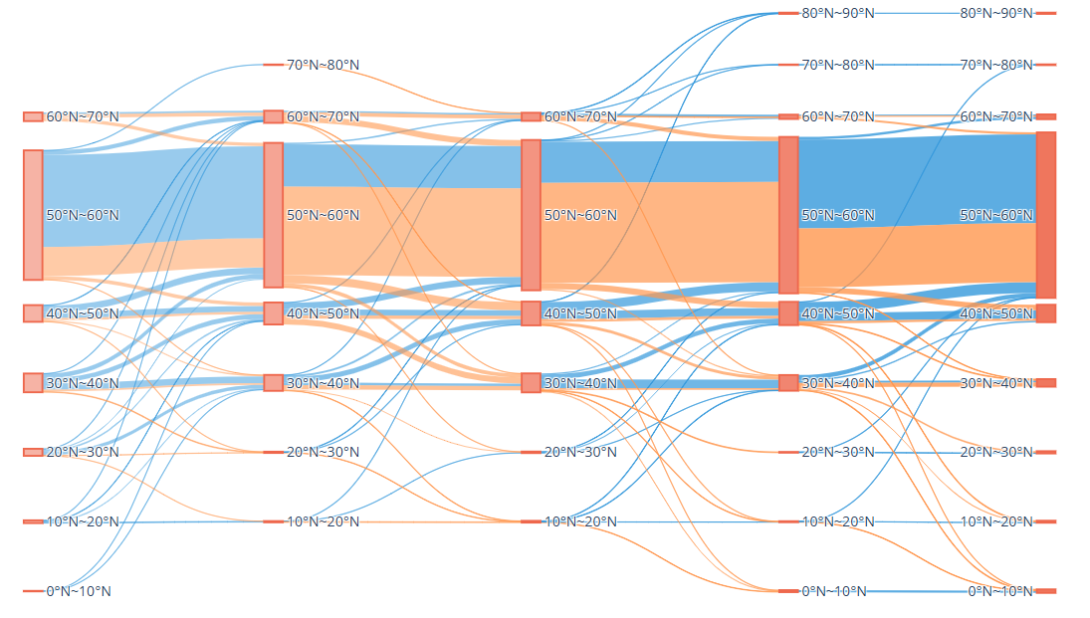

Directional shifts in the latitudinal distribution and temporal changes of the 811 marine families.

**Expected run time:** about 2 mins.

**Note:** The codes in the ‘S3 folder’ and ‘S5–S9 folder’ produce results similar to the figures shown above, therefore, further explanations will not be provided for these files.

**Fig.1B.m**

**Code file name**: Fig.1B.m

**Path of the code file**:

[marine_food_web_research](https://github.com/Casey-bit/marine_food_web_research/tree/main)/[Fig1](https://github.com/Casey-bit/marine_food_web_research/tree/main/Fig1)/ Fig.1B.m

**Input data:** cha.csv

**Expected output**: The expected output is ‘Temporal changes in chlorophyll-a concentration across the entire latitudinal gradient in the Northern Hemisphere’, as illustrated below, which is used for the production of Figure 1B in the main texts.

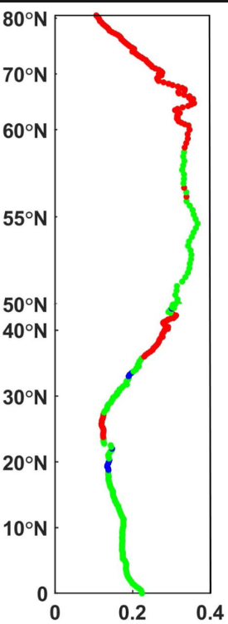

Temporal changes in chlorophyll-a concentration across the entire latitudinal gradient in the Northern Hemisphere.

**Expected run time:** about 1 min.

**(2) Fig2 folder**

**Code file name**: Fig.2.m

**Path of the code file**:

[marine_food_web_research](https://github.com/Casey-bit/marine_food_web_research/tree/main)/[Fig2](https://github.com/Casey-bit/marine_food_web_research/tree/main/Fig1)/ Fig.2.m

**Input data:** DataNew.mat

**Expected output:** The expected output is ‘Direction and magnitude of latitudinal centroid shifts for the 811 Northern Hemisphere marine families, along with temporal changes in their probability density distributions’, as illustrated below, which is used for the production of Figure 2 in the main texts.

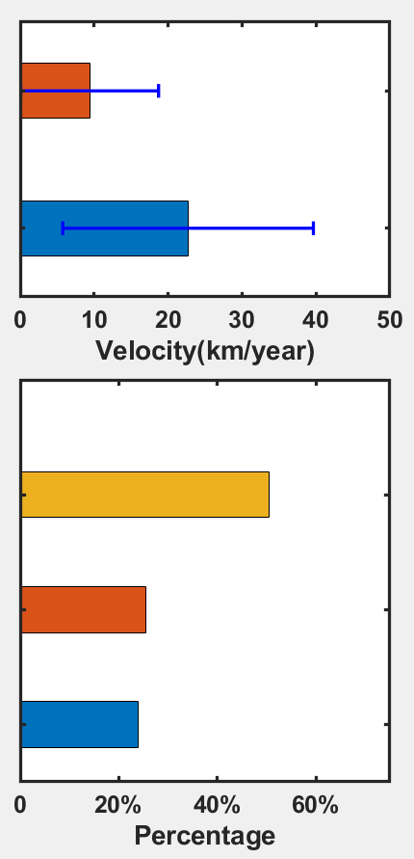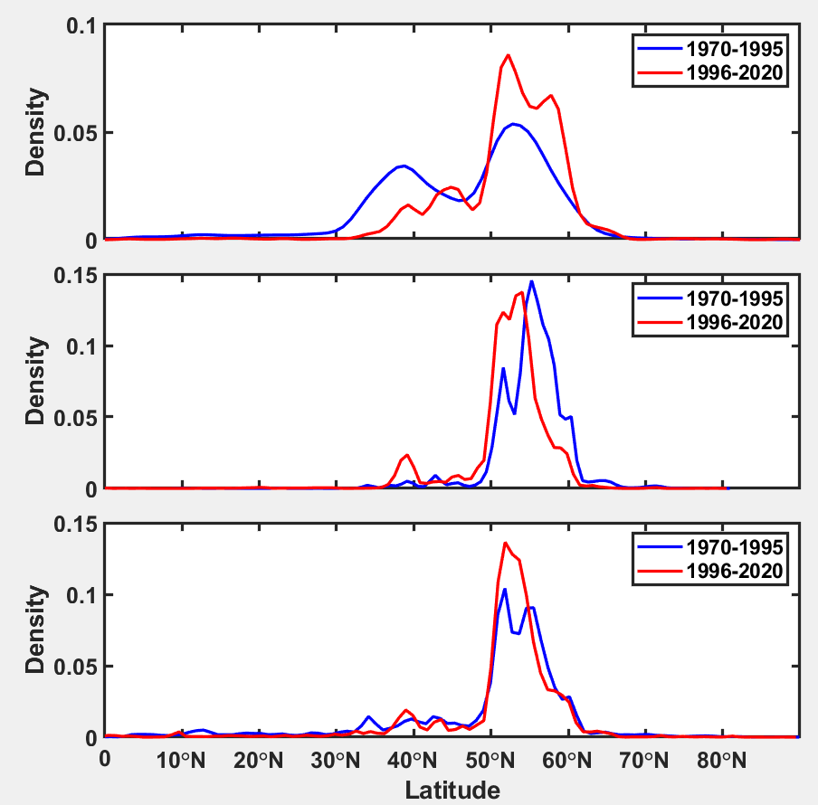

Direction and magnitude of latitudinal centroid shifts for 811 Northern Hemisphere marine families, along with temporal changes in their probability density distributions.

**Expected run time:** about 2 mins.

**Note:** The codes in the ‘S4 folder’, using the same input data, produce the direction and velocity of latitudinal centroid shifts for the 811 Northern Hemisphere marine families, further explanations will not be provided for the ‘S4 folder’.

**(3) Fig3 folder**

**Code file name**: Fig3.m

**Path of the code file**:

[marine_food_web_research](https://github.com/Casey-bit/marine_food_web_research/tree/main)/[Fig3](https://github.com/Casey-bit/marine_food_web_research/tree/main/Fig1)/ Fig.3.m

**Input data:** DataNew.mat

**Expected output:** The expected output is ‘Correlations between the latitudinal positions of families across trophic levels and the latitudinal centroid position of chlorophyll-a concentration’, as illustrated below, which is used for the production of Figure 3 in the main texts.

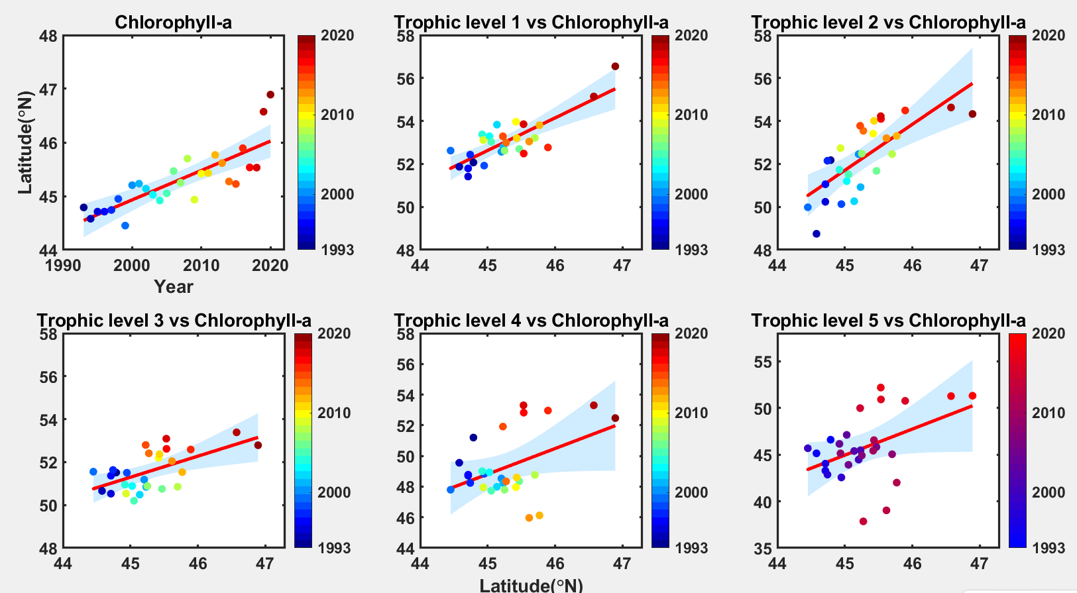

Correlations between the latitudinal positions of families across trophic levels and the latitudinal centroid position of chlorophyll-a concentration.

**Expected run time:** about 2 mins.

**Note:** The codes in the ‘S1 folder’, ‘S11 folder’, ‘S28 folder’ and ‘S30 folder’ produce results similar to the figures shown above; therefore, further explanations will not be provided for these files.

**(4) Fig4 folder**

**Code file name**: Fig4.m

**Path of the code file**:

[marine_food_web_research](https://github.com/Casey-bit/marine_food_web_research/tree/main)/[Fig4](https://github.com/Casey-bit/marine_food_web_research/tree/main/Fig1)/ Fig.4.m

**Input data:** DataNew.mat

**Expected output:** The expected output is ‘Timing of poleward range shifts for marine families across trophic levels’, as illustrated below, which is used for the production of Figure 4 in the main texts.

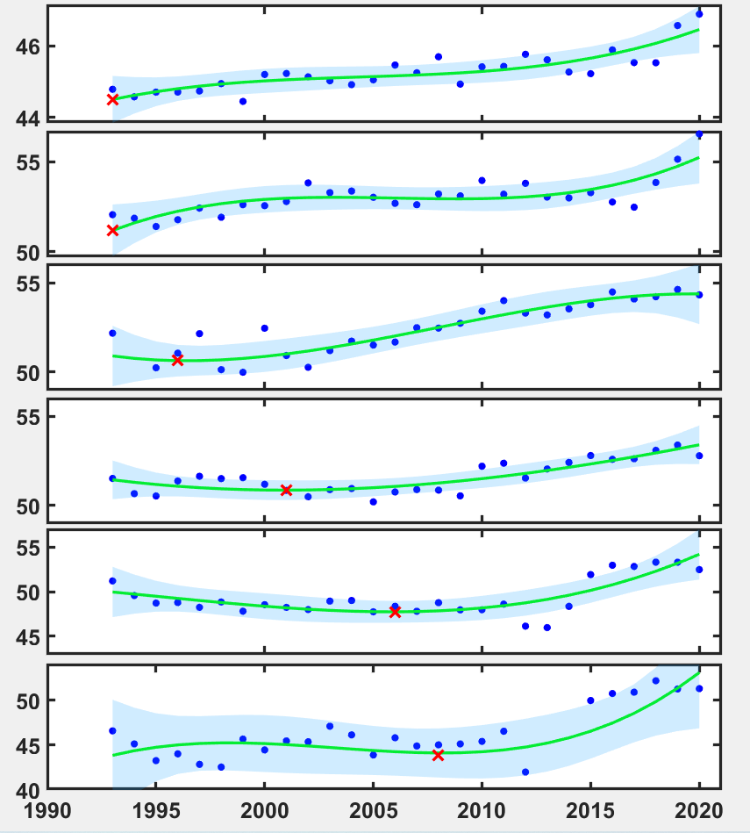

Timing of poleward range shifts for marine families across trophic levels.

**Expected run time:** about 2 mins.

**Note:** The codes in the ‘S13 folder’, ‘S14 folder’, ‘S15 folder’, ‘S29 folder’ and ‘S31 folder’ produce results similar to the figures shown above; therefore, further explanations will not be provided for these files.

**(5) Fig5 folder**

The Fig1 folder contains two executable code files: Fig.5A.gephi and Fig5B1.py.

**Fig5A.gephi**

The professional software Gephi was used to generate and export the figure below, which was used to produce Figure 5A in the main text.

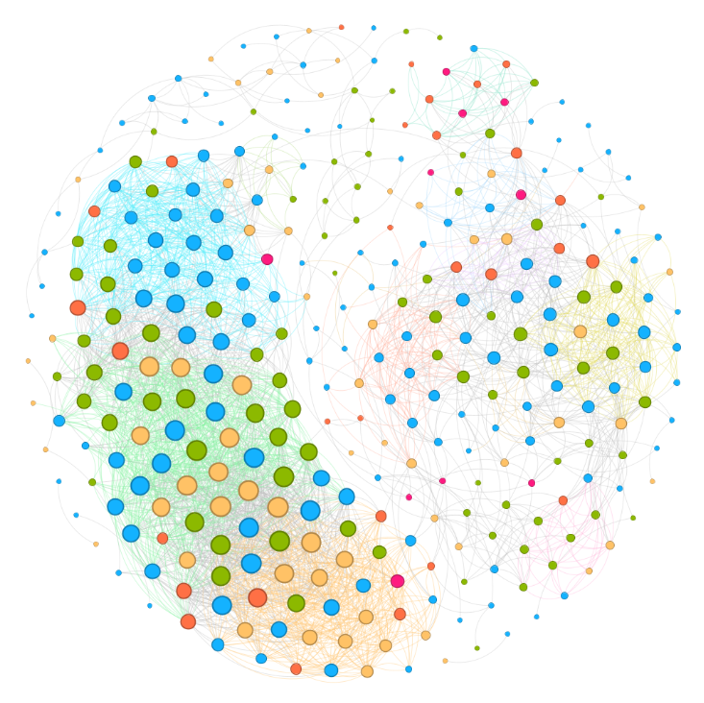

Network of marine families sharing similar yearly time series of latitudinal centroid position.

Fig5B1.py

**Code file name**: Fig5B1.py

**Path of the code file**:

[marine_food_web_research](https://github.com/Casey-bit/marine_food_web_research/tree/main)/[Fig5](https://github.com/Casey-bit/marine_food_web_research/tree/main/Fig1)/Fig5B1.py

**input data:** data_Occurrence.csv, function_group_2.csv, one.png, two.png, three.png, four.png, five.png

**Expected output:** The expected output is ‘The proportion of trophic levels from the first to the fifth level’, as illustrated below, which is used for the production of Figure 5B in the main texts.

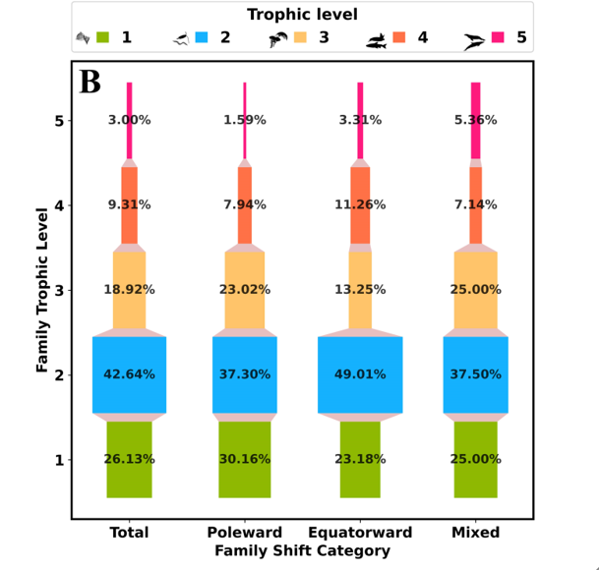

The proportion of trophic levels from the first to the fifth level.

**Expected run time:** about 15mins.

**Note:** The codes in the ‘S17 folder’, ‘S18 folder’, ‘S19 folder’, ‘S20 folder’ and ‘S21 folder’ produce results similar to the figures shown above; therefore, further explanations will not be provided for these files.

**(6) S2 folder**

**Code file name**: S2.m

**Path of the code file**:

[marine_food_web_research](https://github.com/Casey-bit/marine_food_web_research/tree/main)/[S2](https://github.com/Casey-bit/marine_food_web_research/tree/main/Fig1)/ S2.m

**Input data:** data_Occurrence.csv

**Expected output:** The expected output is ‘Density distributions of marine families in the Northern Hemisphere during the period 1970-2020’, as illustrated below, which is used for the production of Figure S2 in the Supplementary Information.

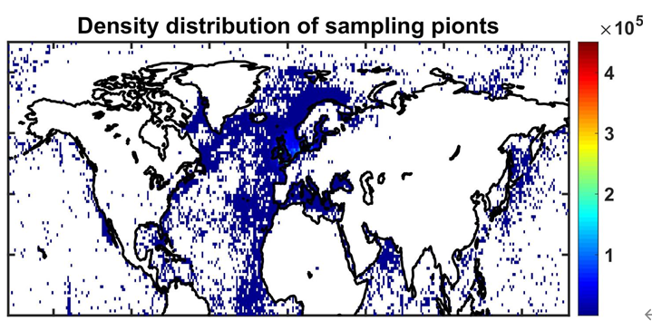

Density distributions of marine families in the Northern Hemisphere during the period 1970-2020

**Expected run time:** about 30 mins.

**(7) S10 folder**

**Code file name**: S10.m

**Path of the code file**:

[marine_food_web_research](https://github.com/Casey-bit/marine_food_web_research/tree/main)/[S10](https://github.com/Casey-bit/marine_food_web_research/tree/main/Fig1)/ S10.m

**Input data:** DataNew.mat

**Expected output:** The expected output is ‘Figures of several example families from the second trophic level exhibiting poleward shifts in their median latitudinal positions’, as illustrated below, which is used for the production of Figure S10 in the Supplementary Information.

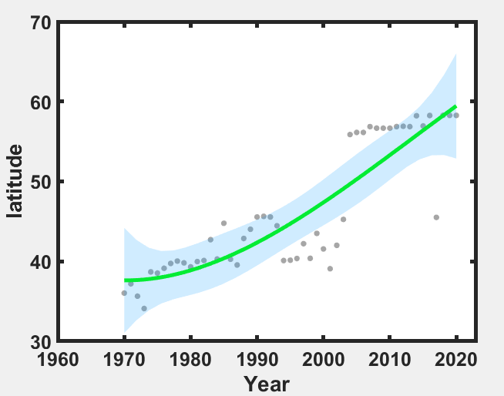

Example family from the second trophic level are shifting their median latitudinal position poleward.

**Expected run time:** about 1 min.**(8) S12 folder**

**Code file name**: S12.m

**Path of the code file**:

[marine_food_web_research](https://github.com/Casey-bit/marine_food_web_research/tree/main)/[S12](https://github.com/Casey-bit/marine_food_web_research/tree/main/Fig1)/ S12.m

**Input data:** DataNew.mat

**Expected output:** The expected output is ‘Figures showing the total sum of squares (TSSE) of fitting errors’, as illustrated below, which is used for the production of Figure S12 in the Supplementary Information.

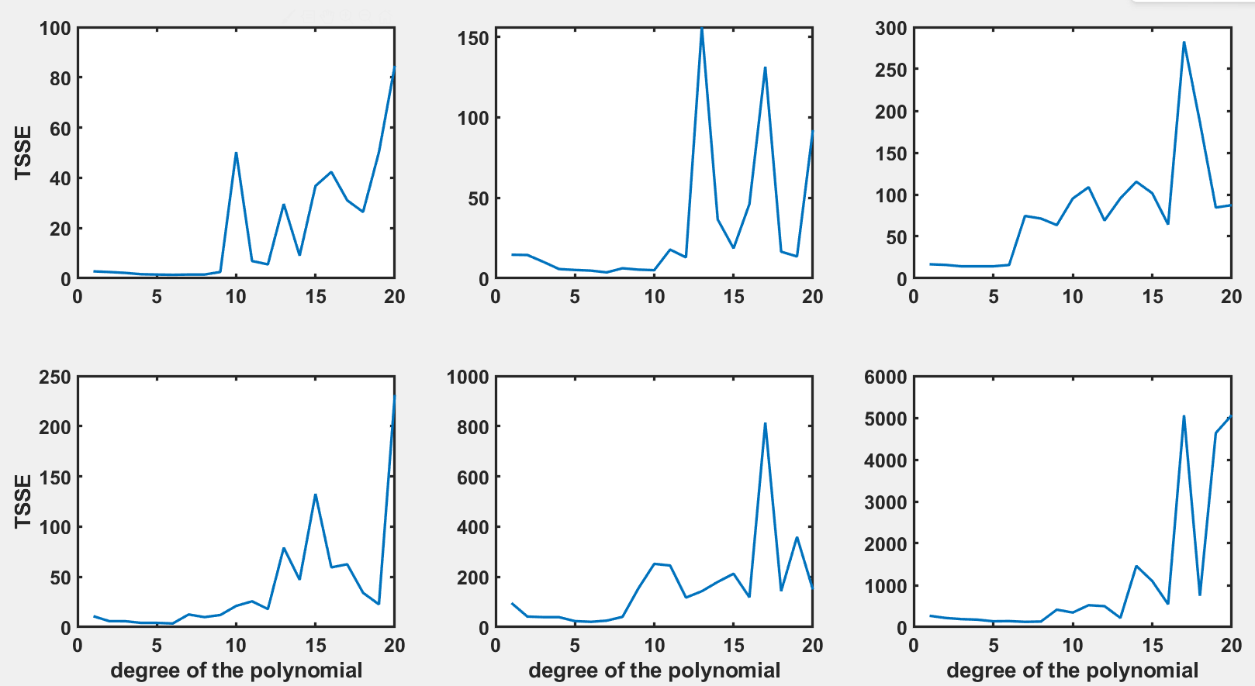

The total sum of squares (TSSE) of fitting errors.

**Expected run time:** about 1 min.

**(9) S16 folder**

**Code file name**: S16.m

**Path of the code file**:

[marine_food_web_research](https://github.com/Casey-bit/marine_food_web_research/tree/main)/[S16](https://github.com/Casey-bit/marine_food_web_research/tree/main/Fig1)/ S16.m

**Input data:** family_year_median_df.csv

**Expected output:** The expected output is ‘Bar charts comparing temporal data fluctuations before and after applying the sliding time window’, as illustrated below, which is used for the production of Figure S16 in the Supplementary Information.

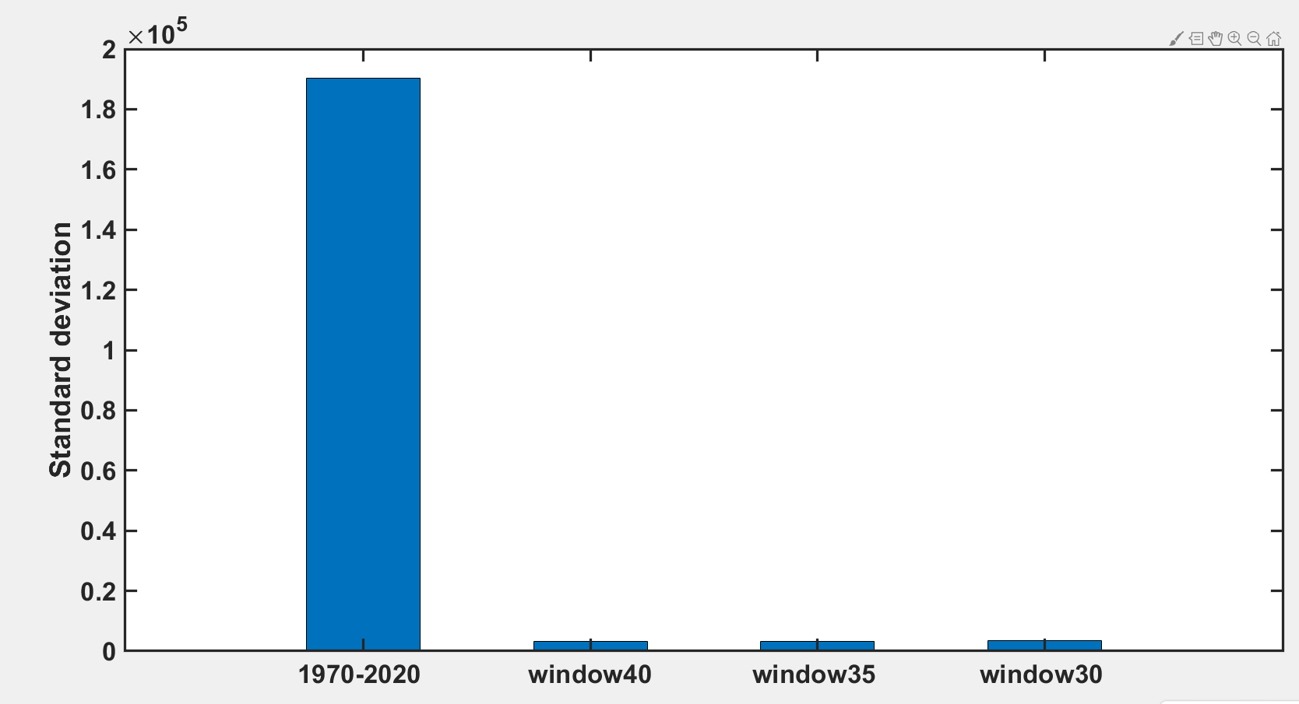

Comparison of data fluctuations in time before and after using a sliding time window to process the data

**Expected run time:** about 1 min.